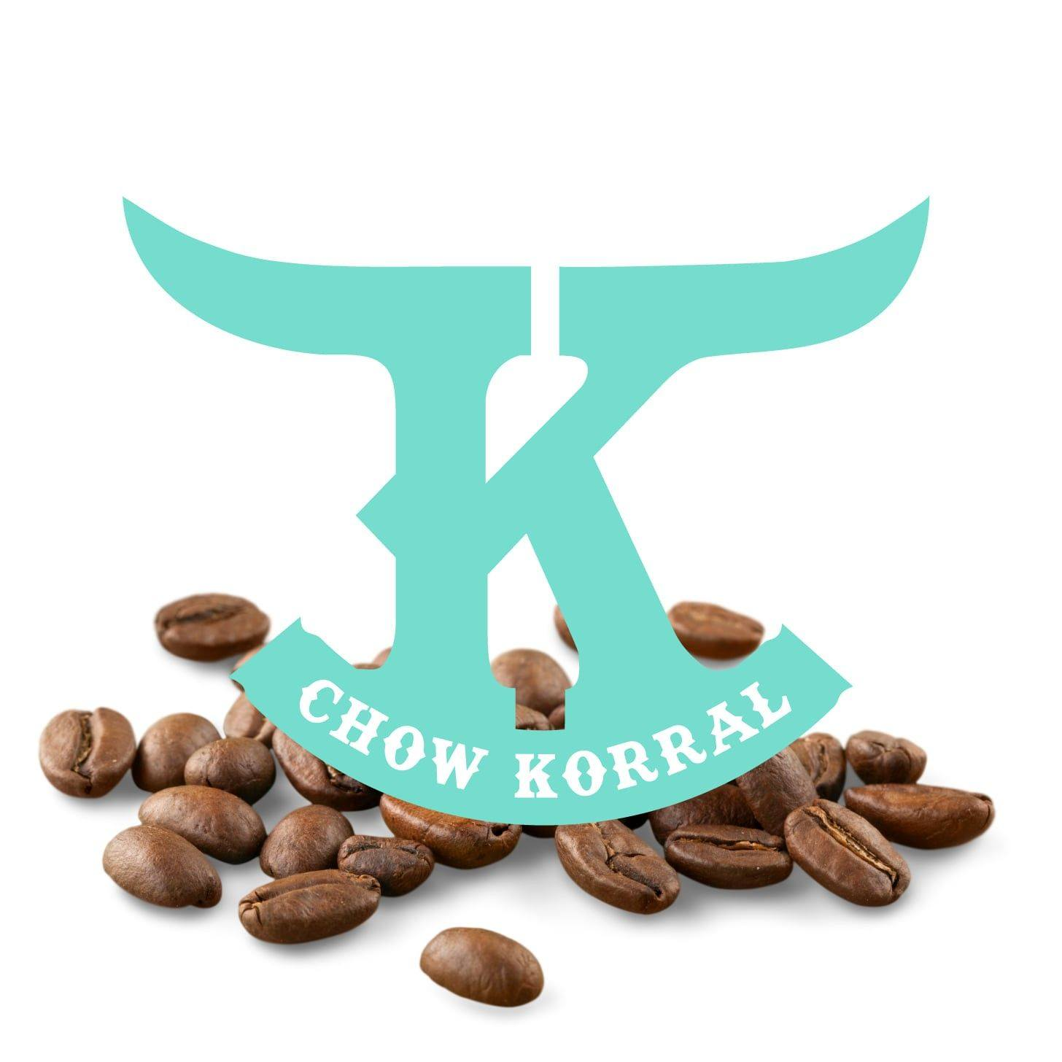

Strategic Marketing Project Final Paper Team #2

Juniata College

MBA/ORG520 Strategic Marketing Management

Client: Chow Korral

Haili, Karissa, Chloe, Jordan C, Zhorea, Kevin, & Patelin

Overview (Karissa)
The Chow Korral is an established coffee shop and bakery in Huntingdon, PA. Kris Runk began the company in 2022, originally starting as a food truck moving from location to location in Arizona before securing a physical residence in Huntingdon in 2024. She opened the business with money she had saved without using a loan, jumping right into the business. She didn’t begin with much of a business plan and says she started the company out of grief. She entered the military right out of high school and moved to Pennsylvania to be with her husband. She lost her father, which caused her to miss her family and home in Arizona, so she began Chow Korral. The goal was to combine her military roots with her western roots-- Chow means food in the military and Korral means to gather-- trying to capture everything she missed from home. Her main draws are her homemade baked goods and a drink called the Dirty Soda which is popular in Arizona and something she grew up with.
Target audience is important when assessing a business plan for Chow Korral, which we feel could increase brand awareness in a town already full of family-oriented and community-driven businesses. Many of her customers will likely be blue-collar and service industry workers, educators, and students of all ages likely from middle-income homes. Customers will be looking for affordable dining from a warm welcoming business that provides a sense of community. The business will have repeat customers from Huntingdon and may experience infrequent customers simply passing through the town, so it’s important to establish a relationship with residents.
Our goal is to increase the restaurant’s weekly customer count by attracting more local families and college students through targeted promotions and events. We want to position Chow Korral as a standout dining destination by improving its online visibility, engaging their customer base, and streamlining its communication channels. With our efforts, we hope to achieve a noticeable increase in customers over the next 3 months to understand how our plan affects growth. What we believe to be achievable is to host a marketing campaign targeted at families in the Huntingdon community to establish our family-oriented and community-driven image. Hosting special events for the community and at Juniata College specifically at least once a month can help with preserving this image. Boosting customer traffic aligns with Chow Korral's goal to strengthen its presence in the Huntingdon community and increase revenue, so we hope to establish our plan before the end of the year and track progress for the first couple of months in 2025 to see if we met our goal in customer growth.

SWOT Analysis (Zhorea)

Strengths  - Unique demographics attributed to the owner of being a woman who is both a veteran and a nurse sets Chow Korral apart from competition.  - Offers unique infusions of Central Pennsylvania and Arizona bakery and beverage staples with consideration for food sensitivities.  - Quality Homemade products | Weaknesses  - No formal business plan.  - Inconsistent branding across media platforms and mobile ordering site.  - Lack of visibility both physically and virtually
Opportunities  - Funds allocated for Social media marketing  - Promotions to bring awareness to brand and products  - Branded website to include mobile ordering | Threats  - local established coffee shops  - located outside Campus walking distance

After analyzing the Chow Korral using the SWOT analysis, we identified several strengths, weaknesses, opportunities for improvement, and threats to the business. The Chow Korral has three main strengths, the first being the owner who is both a veteran and a nurse and the fresh perspective that the business offers Community members of huntingdon through innovative Western inspired baked goods, coffee, acai bowls, dirty soda, and several gluten free options. For example, the Chow Korral has taken Pennsylvania baked staples and transformed them by incorporating her Arizona roots to make dynamic brand staples like dirty sodas which include soda with flavored syrup and cream, and whoopie cookies which sandwiches icing between two cookies instead of the traditional "Gobb" or "Whoopie pie”.
The Chow Korral's weaknesses include marketing, brand awareness, and location. The Chow Korral was founded by an Arizona native who migrated to Pennsylvania and began operations without a formal business plan, as the owner did not have any advisors or mentors to guide her through the process of building a business. With nearsighted visions of the business's trajectory, the owner chose a name for the business to reflect her Western beginnings, but it does not give any insight to the types of items the owner is selling. Moreover, the business is located outside of walking distance for college students, making it difficult to target customers without strategic marketing on social media and other digital platforms.
Though Huntingdon, PA is a small town, it has several unique opportunities that the Chow Korral can use to its advantage. The business can incorporate the Western Culture into the overall brand and promote that brand and unique offerings to the community through social media marketing, promotional events and items. The business also does not have a formal website, but does have a mobile ordering site. There is an opportunity for the business to create a branded website with mobile ordering integrations.
Chow Korral is a unique and dynamic coffee shop that has so much to offer, yet threats like competing businesses who are more visible in physical location and online presence present a challenge to the business’s sustainability. The owner described that there are consumers who want to find a new coffee shop, but they are not coming to Chow Korral because the Huntingdon Community has low awareness of this relatively young business.

Objective 1- Branding Consistency (Haili)

Our first objective is to work with the owner to decide upon a cohesive brand image that will be adhered to across the board. Chow Korral’s transition from a food truck to a brick-and-mortar location has brought many changes and there is a clear need for consistency in branding. The owner has a very interesting backstory and a unique connection to the western image that was featured in the food truck’s aesthetic and the brand’s logo. Her history gives the brand a personality that aligns with the teal color and western fonts used. Committing to this image moving forward and consistently utilizing it across all online platforms, in the food truck, and in the permanent location will ensure that Chow Korral distinguishes its brand from its competitors.
Chow Korral’s primary competitors are Standing Stone Coffee Company, Downtown Joe, and The Roast Post. These coffee shops have an established presence in the community and their own individual brand images. Standing Stone Coffee Company has a warm aesthetic and a neighborly personality that is apparent from their online presence. Downtown Joe’s image is modern and trendy, while The Roast Post’s Instagram is lined with well curated images to accompany specialty drink announcements. Chow Korral’s western vibes are a true differentiator for them and commitment to this brand image will ensure that they stand out from the competition.
In addition to its brand image and personality, Chow Korral’s unique product offerings help to further differentiate it from its competitors. The owner, missing her favorites from back home in Arizona, decided to make some of them herself and serves up these offerings at the Chow Korral. Some items, such as their specialty cinnamon rolls, are variations of commonly found classics. Other items are new to the region and align well with the brand. This includes the “dirty soda”, which is a very popular beverage in the western United States consisting of soda with flavored syrups and cream. Continuing to offer items that are new and innovative for this market and have significant relevance to the brand image will work to solidify the brand to the consumer.

Objective 2- Online Presence (Patelin)

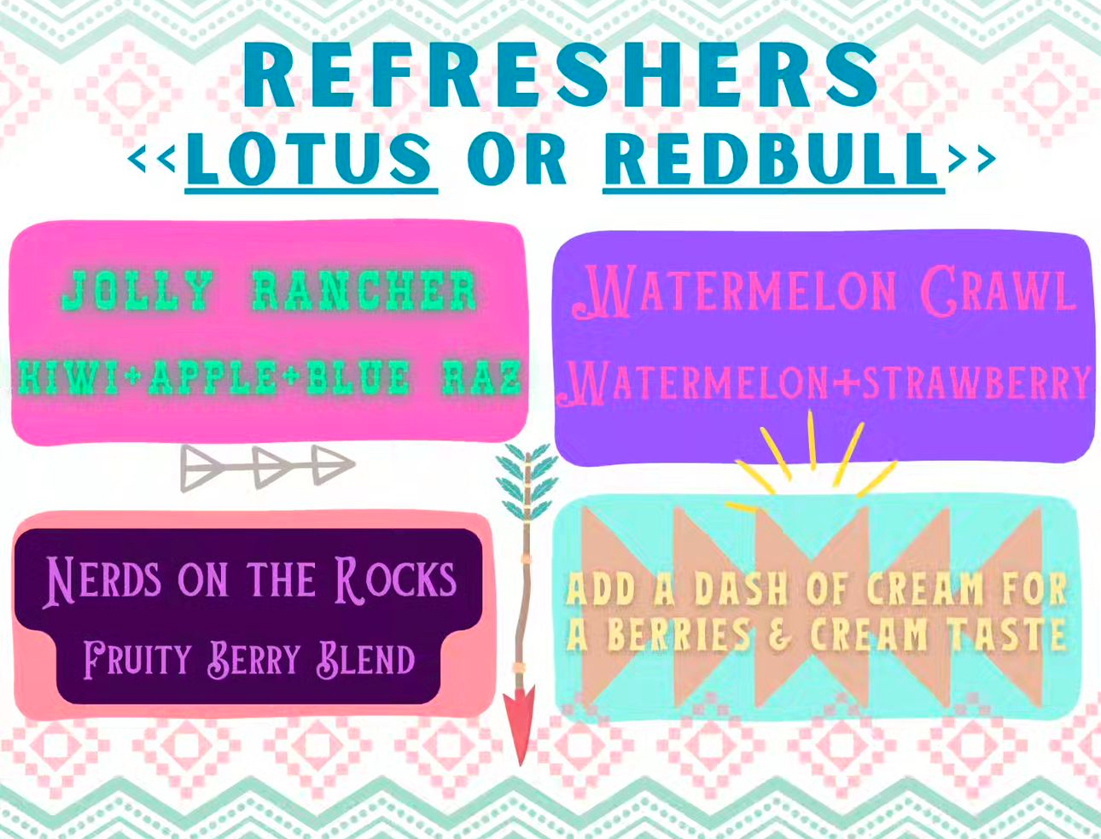

From our conversations with Chow Korral, we learned that the owners' marketing knowledge and efforts are limited, so it makes sense that their online presence is struggling a bit. To strengthen Chow Korral’s online presence, we would first recommend creating and following brand guidelines and using those brand guidelines to create content for their social media platforms and website. Currently, a bright teal color is the most consistent color used across their social media platform. This color is used to promote the Western vibes the owner would like to bring to her shop from Arizona, where she is from. Other than the teal, the other colors and fonts used on their social media platforms vary a lot, giving the platforms a lack of consistency. We believe there is a lot of potential with their current logo, which incorporates teal, brown, and white (picture right.) The other random bright colors and patterns, and often an inconsistent shade of teal (pictured left), make it difficult for Chow Korral to create a consistent, easily identifiable brand identity. Once Chow Korral establishes its brand guidelines, it can implement them across its social media platforms, as well as use them to create a website.
In addition to branding inconsistencies on their social media, there are also a few other areas that have room for improvement, mostly all centered around the type of content that is posted. Currently, the owner posts a lot of content about herself and her family which makes the page a bit confusing to users. It is hard to tell if the account is a business account or a personal account, and coupling that with branding inconsistency, I think it is hard for users to engage. However, we do believe there are benefits to putting a personal touch on a business account. Balance is largely important, and right now it seems more personal than business. Additionally, personal content can be used to engage customers and form closer relationships. Instead of just posting about her weekend plans, she could frame it in a more engaging way that ties back to the business, for example, “the holidays are keeping my family and I extra busy, but a cup of our signature coffee is making it much easier- what is your favorite holiday tradition?” These small changes to the content that she is already sharing can have huge impacts on consumer engagement.
In addition to improvements on their social media platforms, Chow Korral should consider creating a website to improve their online presence. Having a website opens so many doors for growth in a business. For Chow Korral specifically, they would have a space to write more content that would explain their story (a pain point the owner discussed), a space to create a calendar of events, which would promote engagement with the community, sell merchandise, and overall create a more central hub for their brand. There are many steps that Chow Korral can take to improve its online presence, but creating consistent brand guidelines, improving social media content, and creating a website are all great steps that would open even more doors for them.

Budget (Kevin)

To implement the proposed strategies, Chow Korral should allocate a reasonable budget over the next six months to address key areas of improvement. This includes investing in website development to integrate mobile ordering, which will provide convenience for customers and streamline the ordering process. A user-friendly and efficient online experience will enhance the customer journey and increase the likelihood of repeat business.
Additionally, professional branding services should be utilized to establish consistent brand guidelines, ensuring that the business is easily recognizable and appealing. Strong branding will help Chow Korral differentiate itself from competitors and create a lasting impression on potential customers.
Social media marketing will play a key role in enhancing online visibility through targeted advertisements and engaging content, helping to reach more potential customers. With a weekly budget of $20 to $50 on Facebook and Instagram ads—at the lower end of the spectrum—Chow Korral can expect to reach 2,000 to 5,000 local residents, specifically targeting college students, faculty, and community members (Facebook). The geotargeting capabilities of Meta ads allow for precise audience segmentation, ensuring that the ads are seen by those most likely to visit. Tracking the performance of these ads will also allow Chow Korral to refine their approach and maximize the impact of each campaign.

In addition, funds should support promotional events designed to engage the local community and create buzz around the restaurant. Local promotional events can range from $500 to $2,000, covering event materials, food, signage, and other expenses aimed at fostering connections with local residents.
Finally, signage in high-traffic areas should be prioritized to increase awareness of Chow Korral’s location. Given that Chow Korral is located on the main highways, where many cars pass by, high-visibility signage is especially important. Costs for signage can range from $500 to $3,000, depending on location and type. Digital signage may cost more, while printed signs and banners could be more affordable, making it a good option for a visible location like Chow Korral’s.
By combining these digital efforts with local promotional events and high-visibility signage, Chow Korral can significantly increase its presence in the community and build a solid foundation for future growth. These investments are designed to strengthen the brand, enhance the customer experience, and position Chow Korral for long-term success.

Evaluation (Jordan)

Chow Korral’s Facebook page currently has 2.8k likes and 3.3k followers, 25 Facebook reviews with a rating of 4.8, 835 Instagram followers, and 17 Google reviews with a rating of 4.9. Since Chow Korral is a new physical business within the Huntingdon community, it is important to follow up with consumers to get an idea of the public’s perception of the business. Receiving feedback would help provide insight into this. Feedback would be requested after each card transaction either through email or text if the customer provides that information. Baristas and the owner would verbally remind customers after each transaction to leave a review. In the drive-through and the indoor counter, there would be visual queues such as a sign and a QR code to leave a review; this would be great for customers who pay with cash. This link would lead to Chow Korral’s Square feedback link for anonymity. If the person feels comfortable, they have the choice to leave a Google review instead. The feedback from Square and Google can then be imported as posts into Facebook and Instagram to create content and engage with followers. We would be able to compare the recent feedback to the previous reviews and to understand how the proposed changes for brand consistency, and the perception of the brand, its story and offerings has resonated with the community.
To measure online presence, Chow Korral can create a monthly drawing on Facebook and Instagram where people can win a free bundle, such as a specialty drink and baked goods only for in-person pick up. People can make a comment leaving feedback on what they like about Chow Korral, invite someone to follow Chow Korral’s page, and like and share the post. Facebook and Instagram are easily accessible for viewing post insights, and the effectiveness of each post and advertisement is easily measurable, such as determining the click through rate. Since Chow Korral has amazing ratings, the priority is to maintain the Facebook and Google reviews and prioritize creating a “viral word of mouth”, to bring more visibility to its Facebook and Instagram pages, and highlight what Chow Korral has to offer such as the option for drive-through or indoor seating, dirty sodas, macarons, or the business’s background story.

Conclusion (Chloe)
To address Chow Korral’s challenges and capitalize on its opportunities, our group proposes a series of actionable steps. Phase one, called “Branding and Digital Foundations”, will span over months 1-3. The Chow Korral should develop and implement a cohesive brand strategy that reflects its unique Western theme. Finalizing a brand identity that aligns with the teal, brown, and white color palette used in the logo should create a recognizable and consistent image. Then, this branding should be applied across all platforms, such as social media, mobile ordering, and in-store materials. Furthermore, incorporating storytelling into the brand will highlight the owner’s journey as a veteran and nurse, while blending it with an Arizona and Pennsylvania-inspired menu to create a relatable narrative for customers. A branded website could serve as the hub for the business, integrating mobile ordering, showcasing the menu, and sharing the owner’s story, all in one place. This could also include a blog or event calendar to further engage the community. On social media, the Chow Korral could strike a balance between personal and business-related posts, using this to connect with customers while bringing them back to the offerings. Visually appealing, professionally styled photos of menu items and promotions that align with the aesthetic will help the business stand out and attract more engagement from followers.
Boosting community awareness is another crucial step, leading into phase two, “Community Engagement”, following months 4-6. Hosting monthly promotional events, like “Taste of the West” nights, that would allow customers to sample signature items, such as dirty sodas and baked goods, showcasing unique offerings. Partnering with local organizations to cater or offer exclusive discounts can also strengthen community ties and increase visibility. Additionally, strategically placing signage near Huntingdon’s college campus and high-traffic areas could draw in those unaware of the business. Phase 3, months 7-9, labeled “Customer Feedback”, will have us using customer feedback and reviews to help build credibility and attract new customers. Furthermore, incentivizing feedback through monthly giveaways can increase participation. Sharing these positive reviews online will validate the brand and attract new customers. Lastly, phase four, “Continuous Growth”, would involve regularly updating, improving, and maintaining the previously mentioned actionable items.
Chow Korral is uniquely positioned to carve out a strong niche in Huntingdon with its Arizona roots, high-quality offerings, and the owner’s compelling story. However, addressing its weaknesses in branding, visibility, and online presence is crucial for boosting success. By implementing this strategy, Chow Korral can distinguish itself from competitors and establish a loyal customer base. These steps will allow the Chow Korral to further grow into a cornerstone of the Huntingdon community.

